Digital Design

CSCE 2114-L007

Blake Fasse

February 13, 2017

[bafasse@uark.edu](mailto:bafasse@uark.edu)

Introduction

The purpose of this lab was to understand how to use the Quartus software to build a simple circuit and how to download that circuit to the FPGA. The FPGA is a printed circuit board (PCB) with integrated chips (IC) on it that have USB interfaces on them so you can plug them into the computer and create circuits or programs in the Quartus software and then download them to the FPGA to be tested.

Design

The lab required to the implementation of the logical function F = A’ ∙ B’ + C’ ∙ D’. The circuit that was built has four inputs, labeled A, B, C, D, and one output, labeled F. Each input was inverted and inputs A’ and B’ were plugged into an AND gate while inputs C’ and D’ were also fed into an AND gate and then the outputs of both AND gates were plugged into an OR gate. A picture of the circuit built in Quartus is shown below.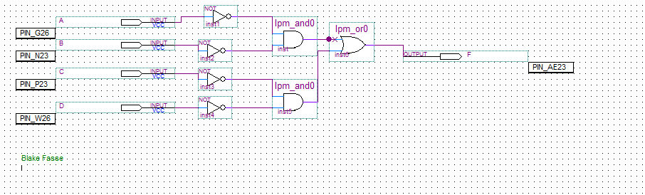

Results

The results of the circuit are as shown in an Excel spreadsheet below. Every input was inverted with inputs A and B and inputs C and D being ANDed together and those outputs are ORed together to give the output F. 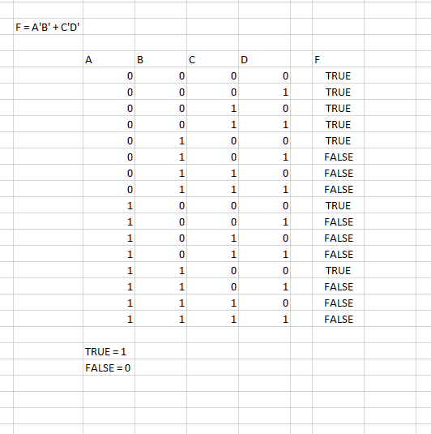

Conclusion

Understanding Quartus makes building circuits a lot easier compared to physically build them using IC’s and wires especially since this circuit has four inputs and uses three IC’s. The FPGA also makes things simpler because instead of just looking at simulated scenario the board allows the physical manipulation of the switches to see what is going on.